KJSCE/IT/SYBTech/SEM IV/AA/2020-21


Experiment No. : 7

Title: Sum of Subset problem using Backtracking

(Autonomous College Affiliated to University of Mumbai)

Batch:B2 Roll No.:1914078 Experiment No.:7
Aim: Implement Sum of Subset problem using Backtracking.

Algorithm:

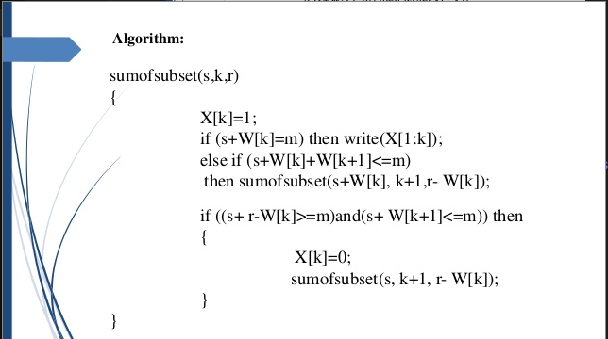

Example of Sum of Subset problem using Backtracking Step by Step Execution

Example array
ARR
0 1 2
2 3 5
Required sum: 5
Set array X[4] and set all elements to 0

S = 0
R = 10
Set X[0] = 1
S+2<5:
Do nothing
S+2 + 3 <= 5:
S = 2
R = 8
X[1] = 1
S + 3 = 5
Print all arr[i] where X[i] = 1
i.e. 2 and 3
Set Elements of X back to 0
Return;
S+10-2>=5 and S + 3 <=5
X[0]=0

S= 0
R = 8
S+3<5:
Do nothing
S+3+5>5:
Do nothing
S+R-3= 5 >= 5 and S+5<=5:
X[1] = 0
X[2]=1
S = 0
R = 5
S+5 = 5:
If X[i] =0 print arr[i], i.e. 5
Set X to 0
Return;

KJSCE/IT/SYBTech/SEM IV/AA/2020-21

Derivation of Analysis:

Time complexity:

- Subset sum problem is to find subset of elements that are selected from a given set whose sum adds up to a given number K.
- We are considering the set contains non-negative values.
- It is assumed that the input set is unique (no duplicates are presented).
- One way to find subsets that sum to K is to consider all possible subsets. A power set contains all those subsets generated from a given set. The size of such a power set is 2^{N}.
- Worst case time complexity: Θ(2^n)
- Space complexity: Θ(1)

Program(s):

#include <bits/stdc++.h>

#define rep(i, n) for (int(i) = 0; (i) < (int)(n); ++(i))
#define reu(i, l, u) for (int(i) = (int)(l); (i) < (int)(u); ++(i))
#define each(it, o) for (auto it = (o).begin(); it != (o).end(); ++it)
#define ios \
freopen("i", "r", stdin); \
freopen("o", "w", stdout);

using namespace std;

int n;

void sumofsubsets(int s, int m, int k, int r, int arr[], int X[])
{
X[k] = 1;
if (k < n)
{
if (s + arr[k] == m)
{
rep(i, n)
{
if (X[i] == 1)
{
X[i] = 0;
cout << arr[i] << " ";
}
}
cout << endl;
return;
}
if (k < n - 1)
{
if (s + arr[k] + arr[k + 1] <= m)
{
sumofsubsets(s + arr[k], m, k + 1, r - arr[k], arr, X);
}
if (s + r - arr[k] >= m && s + arr[k + 1] <= m)
{
X[k] = 0;
sumofsubsets(s, m, k + 1, r - arr[k], arr, X);
}
}
}
else
{
cout << "Not found\n";
return;
}
}

int main()
{
ios
cin >>
n;
int r = 0, m, s = 0;
int arr[n];
int X[n];
cin >> m;
rep(i, n)
{
cin >> arr[i];
r += arr[i];
X[i] = 0;
}
sort(arr, arr + n);
sumofsubsets(s, m, 0, r, arr, X);
}

Output(o):

Input
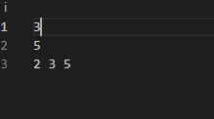
Output
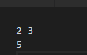

KJSCE/IT/SYBTech/SEM IV/AA/2020-21

Questions:- Explain the process of backtracking ? What are the advantages of backtracking as against brute force algorithms ?
Answer:
Process of Backtracking:
- In Backtracking algorithm as we go down along depth of tree we add elements so far, and if the added sum is satisfying explicit constraints, we will continue to generate child nodes further.
- Whenever the constraints are not met, we stop further generation of sub-trees of that node, and backtrack to previous node to explore the nodes not yet explored. We need to explore the nodes along the breadth and depth of the tree.
- Generating nodes along breadth is controlled by loop and nodes along the depth are generated using recursion (post order traversal).

Advantages of Backtracking Algorithm over Brute-Force Algorithm are:
- It is a step-by-step representation of a solution to a given problem , which is very easy to understand
- It has got a definite procedure.
- It easy to first develop an algorithm & then convert it into a flowchart &then into a computer program.
- It is independent of programming language.
- Tt is easy to debug as every step is got its own logical sequence.
- Brute-force search (BFS) is a type of algorithm which computes every possible solution to a problem and then selects one that fulfills the requirements.
- Explicit constraints give the possible values for each choice (e.g., choices 1-3 are limited to {1, 2}, choice 4 is limited to {3, 4, 5}, etc.), which determines how the search's "execution tree" is shaped.
- Implicit constraints relate the different choices to each other (e.g., choice 2 must be greater than choice 1, etc.), which is used in BFS to remove potential solutions.
- Backtracking is an extension to BFS in which the implicit constraints are evaluated after every choice (as opposed to after all solutions have been generated), which means that potential solutions can be discarded before they have been 'finished'.

Outcome:
Understand Backtracking and Branch-and-bound algorithms

Conclusion: (Based on the observations):

Successfully implemented solution of Subset problem using backtracking approach.

References:

- Richard E. Neapolitan, " Foundation of Algorithms ", 5th Edition 2016, Jones & Bartlett Students Edition

- Harsh Bhasin , " Algorithms : Design & Analysis", 1st Edition 2013, Oxford Higher education, India

- T.H. Coreman ,C.E. Leiserson,R.L. Rivest, and C. Stein, " Introduction to algorithms", 3rd Edition 2009, Prentice Hall India Publication

